Dataset1
Data Dimensionality & Integrity Analysis
- Methodology
To accurately assess the dimensionality and health of the Traffic Accidents dataset, we moved beyond standard technical profiling (e.g., simple type checking and null counting). Instead, we implemented a semantic analysis approach:
  - Variable Type Inference: We classified variables based on their content rather than their data type. For example, columns with exactly two unique values were classified as Binary, and text strings representing dates were validated and classified as Date.
  - Implicit Missing Value Detection: Crucially, we recognized that in administrative datasets (like police reports), missing information is often recorded as text placeholders rather than empty cells. We scanned all symbolic variables for indicators such as "UNKNOWN", "UNABLE TO DETERMINE", and "NOT APPLICABLE" to reveal the true sparsity of the data.
  - Dataset Structure
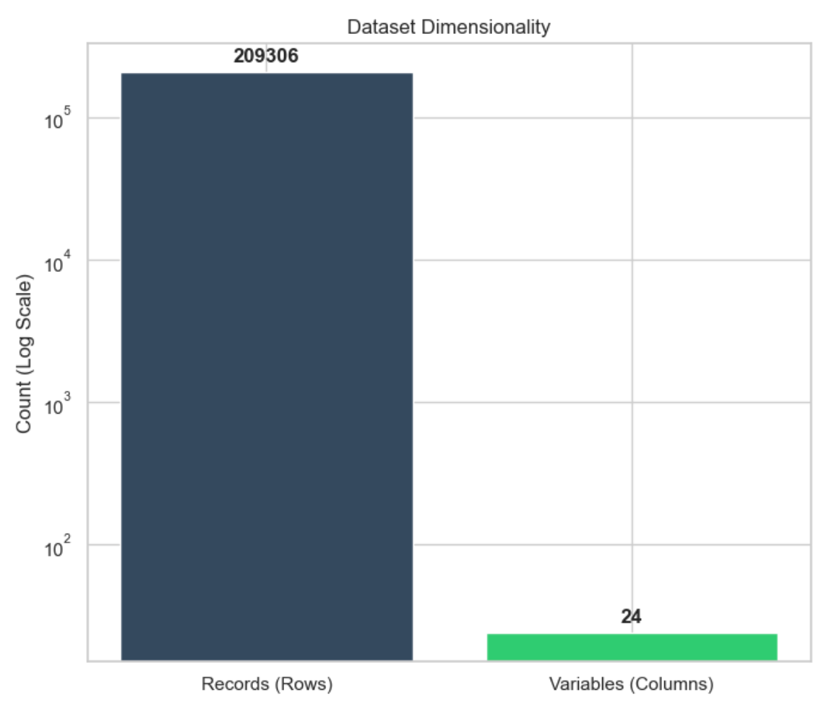
Ref: Figure 1 (Nr of records vs Nr variables) The dataset consists of 209306 records and 24 variables. As shown in Figure 1, the ratio of records to variables is high (indicated by the logarithmic scale required to visualize both). This "tall" dataset structure is generally favorable for machine learning, providing ample examples for the model to learn patterns, provided the feature quality is high.
  - Variable Types
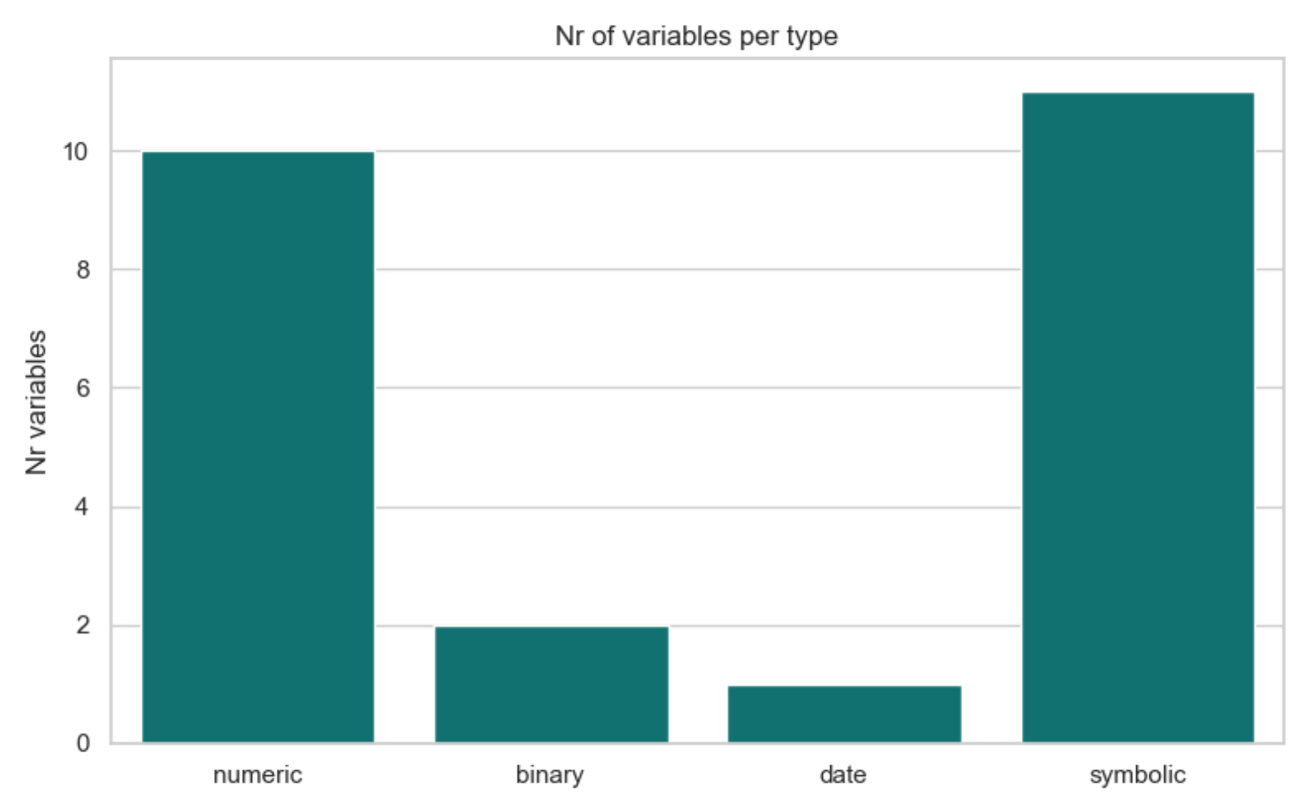
Ref: Figure 2 (Nr of variables per type) Our semantic type inference revealed a diverse mix of features:
Symbolic (11 variables): A significant portion of the data is categorical (text-based). This indicates a high requirement for encoding (One-Hot or Label Encoding) during the preparation phase.
Numeric (10 variables): Includes count data (e.g., injuries_total) and continuous data.
Binary (2 variables): We successfully identified columns like intersection_related_i and crash_type (after processing) as binary, which simplifies their modeling treatment.
Date (1 variable): The crash_date was correctly identified, which will allow for granular temporal analysis (Month/Hour) later.
  - Data Integrity (The "Hidden" Missing Values)
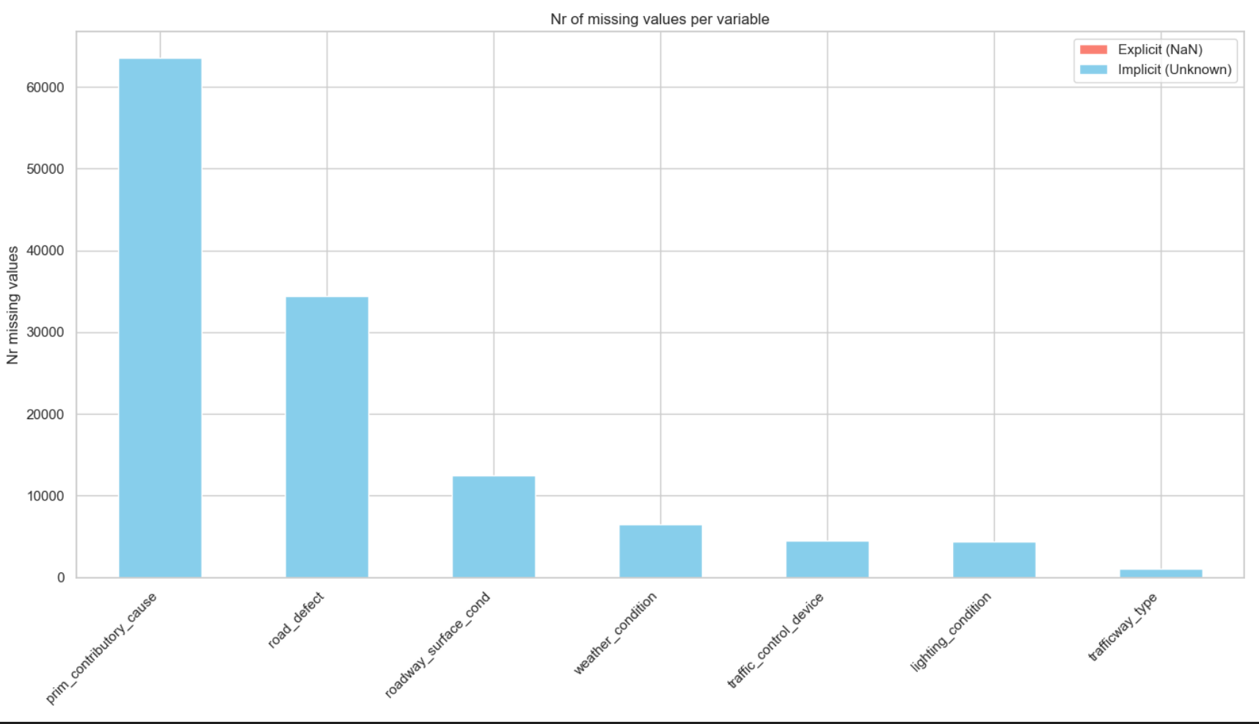
Ref: Figure 3 (Nr of missing values per variable)
This section highlights the most critical finding of our dimensionality profile. A standard technical check (df.isnull().sum()) would have reported this dataset as having no missing values. However, by accounting for Implicit Missing Values (shown in Blue), we discovered significant data quality issues that were previously hidden:
The "Unknown" Problem: Variables such as road_defect, roadway_surface_cond, and primary_contributory_cause show a massive volume of implicit missing data (entries labeled "UNKNOWN" or "UNABLE TO DETERMINE"). So for many variables, the majority of the "data" is actually just a placeholder for a lack of knowledge.
Consequences & Strategy
The discovery of high implicit missingness has major consequences for our next steps:
Modeling Validity: We cannot treat "UNKNOWN" as a standard category in all cases. For example, if a model learns that Road Defect = "Unknown" is a strong predictor of accidents, it provides no actionable safety insight.
Future Action: In the Data Preparation phase, we must decide on a column-by-column basis whether to:
Impute: Replace "Unknown" with the most frequent value (mode).
Keep: Retain "Unknown" only where the lack of information is itself a meaningful signal (e.g., in hit-and-run scenarios).

Distribution
To understand the underlying behavior of the data, we analyzed the distribution of both numeric and symbolic variables. This analysis is critical for selecting appropriate scaling techniques and predictive models in later stages.

- Numerical values
2.1 Global Overview & Scale Analysis
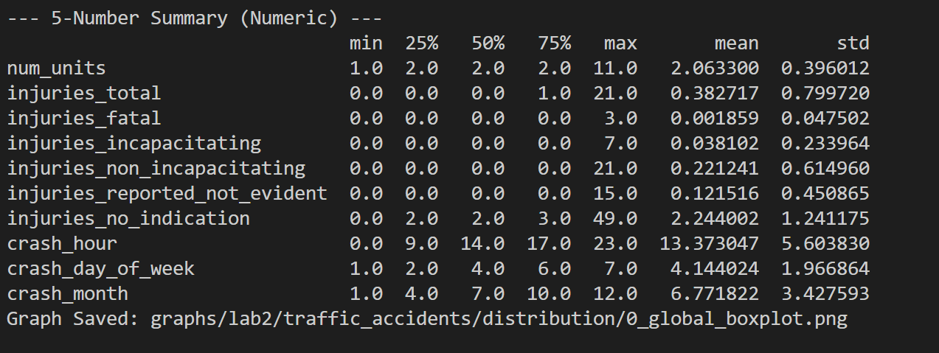
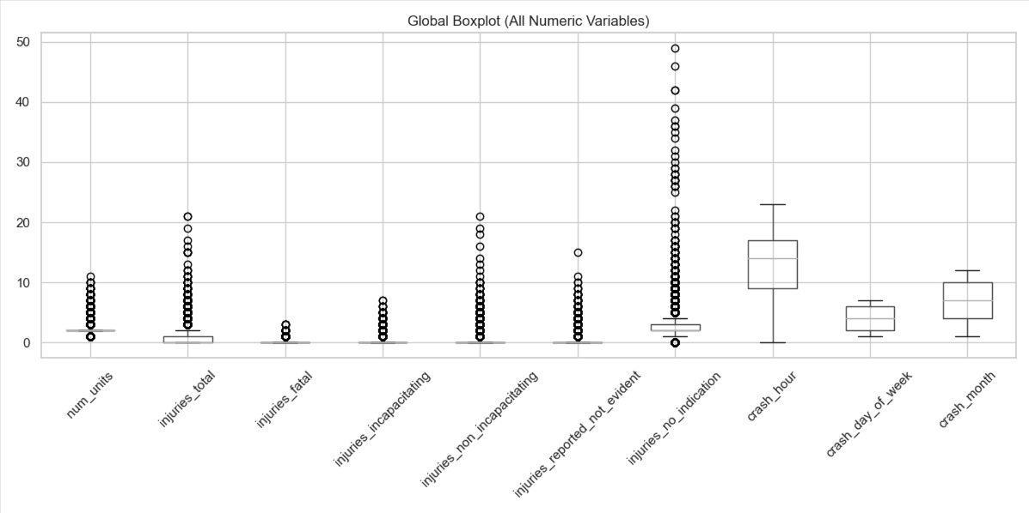
Ref: Figure 4 (Global Boxplot - All Numeric Variables) To obtain an initial overview of the numeric data, we plotted the distribution of all numeric variables side-by-side. As seen in Figure 4, this visualization highlights two critical characteristics of the dataset:
Scale Disparity: There is a significant difference in ranges. Temporal variables like crash_hour range from 0 to 23, whereas casualty variables (e.g., injuries_fatal) have a median of 0 and a much smaller interquartile range. This disparity caused the casualty variables to appear "flattened" on the global chart.
Zero-Inflation: The casualty variables (injuries) exhibit extreme zero-inflation. The "box" in the boxplot (representing the middle 50% of data) is collapsed into a single line at 0, indicating that for the vast majority of accidents, no injuries occur. The visible points above the zero-line represent the outliers (accidents with casualties).
Absence of Outliers in Temporal Variables It is noteworthy that the temporal variables (crash_hour, crash_day_of_week, crash_month) exhibit no visible outliers in the global boxplot. This is expected behavior for variables defined within a fixed, closed domain (e.g., 0–23 for hours). Unlike casualty variables, which are zero-inflated with a tiny Interquartile Range (IQR), temporal variables exhibit high variance across their entire valid range. Consequently, the statistical whiskers extend sufficiently to encompass the minimum and maximum values of the domain, leaving no data points to be classified as statistical outliers. This confirms that the temporal data contains no impossible values (e.g., "Hour 25") and requires no outlier pruning.
2.2 Distribution Fitting (Histograms & PDFs)
Casualty variables 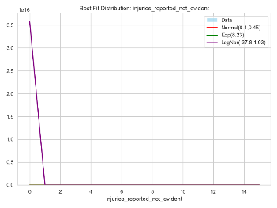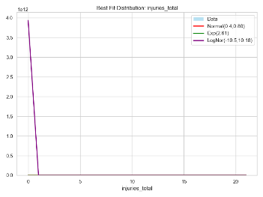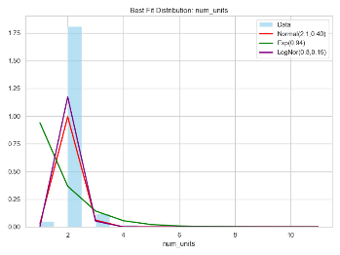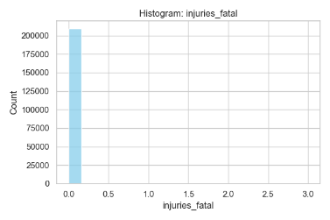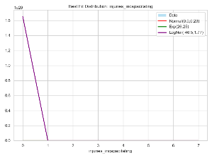

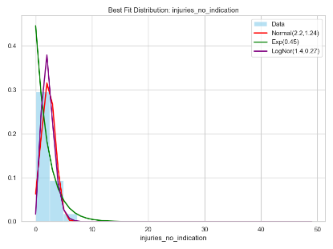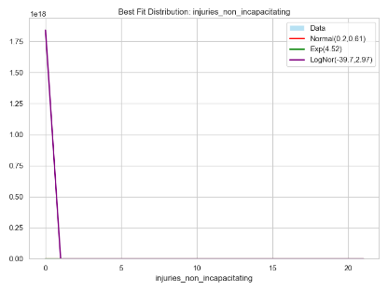
An initial inspection of the casualty variables (e.g., injuries_total, injuries_incapacitating) using standard linear histograms revealed a phenomenon of Extreme Zero-Inflation.
- Visual Observation: The graphs appear dominated entirely by a single bar at the value 0. The density of non-zero values (accidents with actual injuries) is so low relative to the "No Injury" baseline that they are visually compressed into the X-axis, making them appear non-existent.
- Distribution Fitting Failure: The attempted distribution fits (Normal, Exponential, LogNormal) failed to provide meaningful insights on this scale. The Normal distribution (Red line), for instance, attempts to fit a symmetric bell curve around the mean (which is close to 0), resulting in a flat line that completely fails to capture the skewness of the data.
- Conclusion: On a linear scale, these variables appear to possess no variance, which is a misleading artifact of the visualization rather than a property of the data.

Log-Scale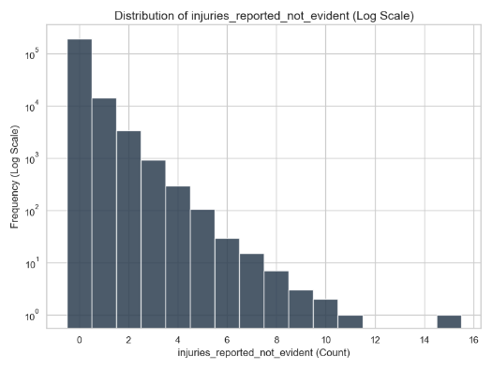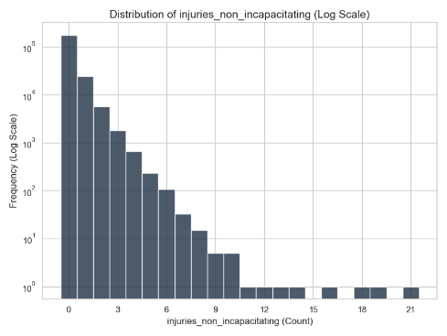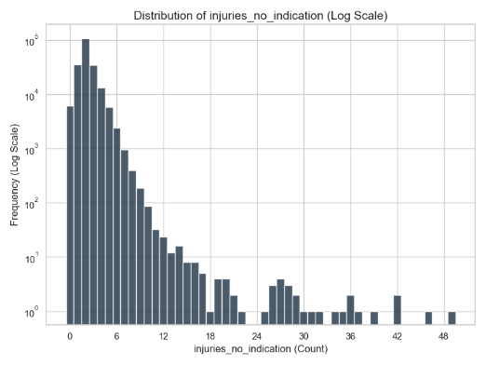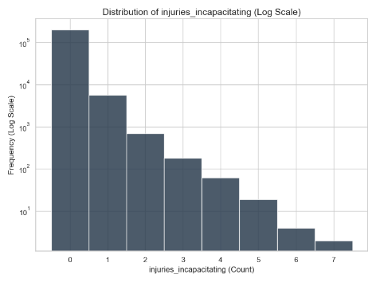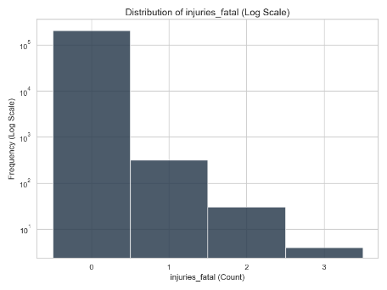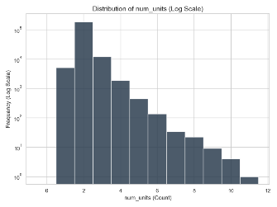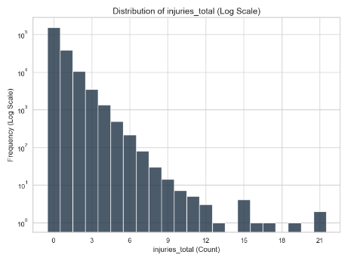To investigate the "invisible" tail of the data, we re-plotted the casualty variables applying a Logarithmic Scale to the Y-axis (Frequency). This transformation successfully revealed the underlying structure of the data:
- Emergence of the Tail: The log-scale reveals a clear, consistent "long tail" distribution. We can now distinctively observe the frequency of accidents involving 1, 2, 3, and even 4+ injuries. This confirms that while rare, these high-casualty events exist and are not
- merely data errors.
Temporal Variables
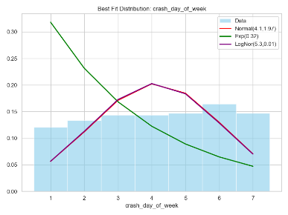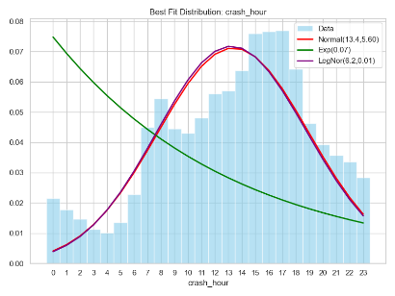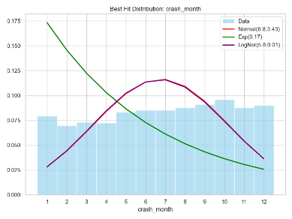
Unlike the casualty variables, the temporal features (crash_hour, crash_day_of_week, crash_month) exhibit multimodal or uniform distributions rather than exponential decay.
- Crash Hour (Bimodal Pattern): The histogram for crash_hour reveals a clear bimodal distribution that mirrors human activity. We observe a trough during early morning hours (1 AM – 5 AM), a sharp rise peaking around the morning commute (8 AM), and a sustained high plateau through the evening rush hour with a peak at 4PM. The attempted Normal distribution fit (Red line) fails to capture this "double-peak" structure.
- Day of Week & Month (Uniformity): Both crash_day_of_week and crash_month show relatively uniform distributions with minor fluctuations. There are no extreme outliers or skewness. This indicates that accidents are relatively consistent across the week and year, though minor seasonal or weekend trends may exist.
- Modeling Implication: Since these variables are cyclical (Hour 23 is close to Hour 0) and multimodal, treating them as standard continuous integers in a Linear Regression model might be suboptimal. Feature engineering (e.g., binning hours into "Rush Hour" vs "Night") may yield better predictive power.

Binary Variables (Histograms)
Ref: Figures [Insert Numbers] (Distributions of Binary Variables)
We identified specific variables that contain exactly two unique values (Binary). The most critical of these is our target variable. 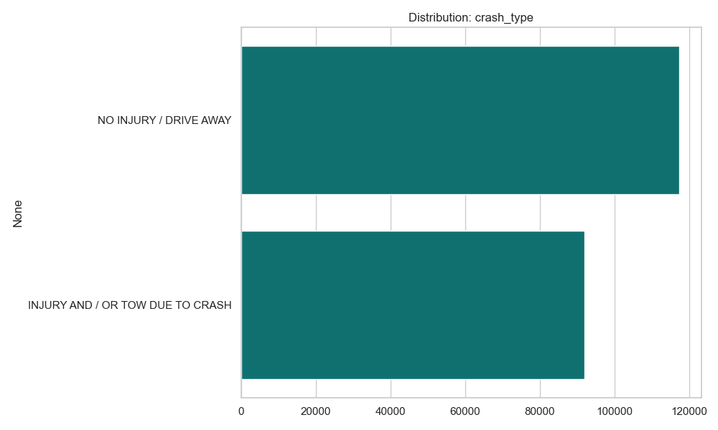
- Target Variable (crash_type):
  - Observation: The dataset is pretty balanced. A slight majority of records belong to the NO INJURY / DRIVE AWAY class, while INJURY AND / OR TOW DUE TO CRASH represents the minority class.
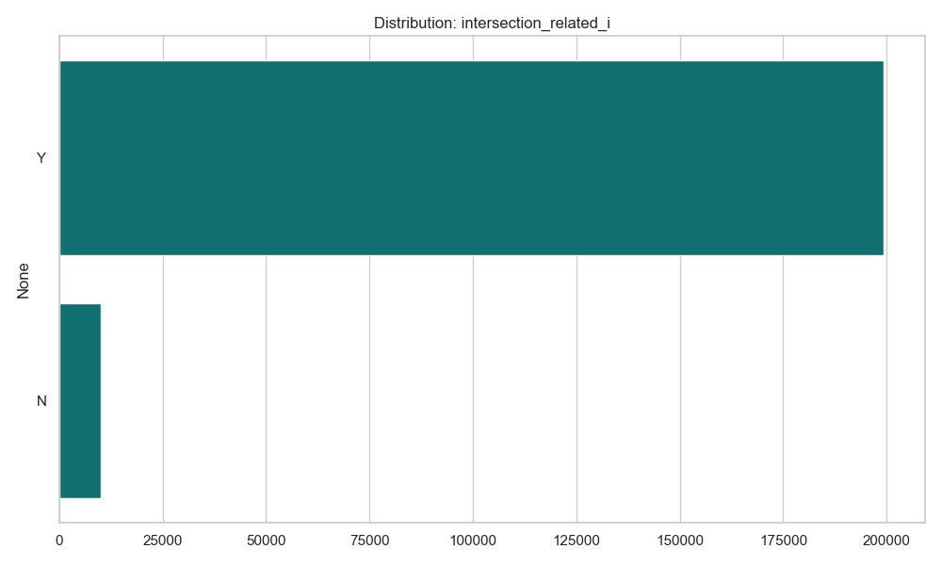
- Other Binary Features (e.g., intersection_related_i):
• Observation: Variables such as intersection_related_i show a clear imbalance, with the majority of accidents occurring away from intersections.
• Implication: These binary flags will serve as key categorical features. Since they are already in a numeric-compatible format (or easily encoded as 0/1), they require minimal preparation compared to the multi-class symbolic variables.
Symbolic Variables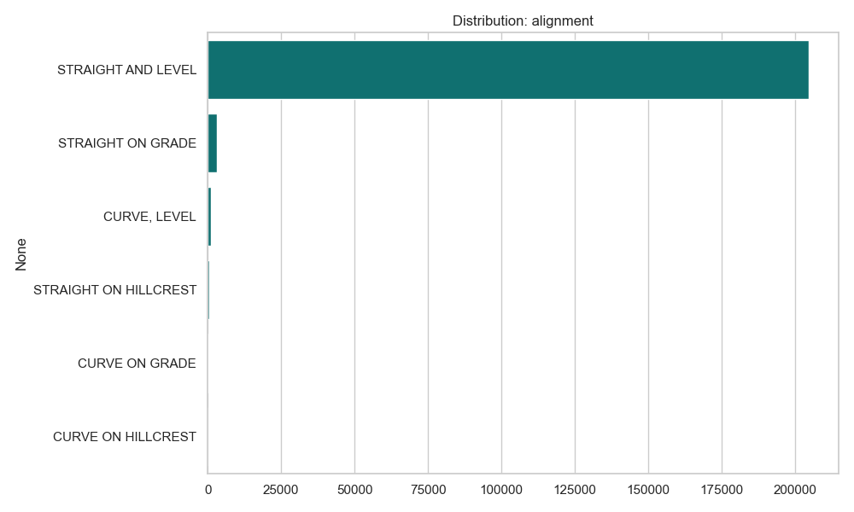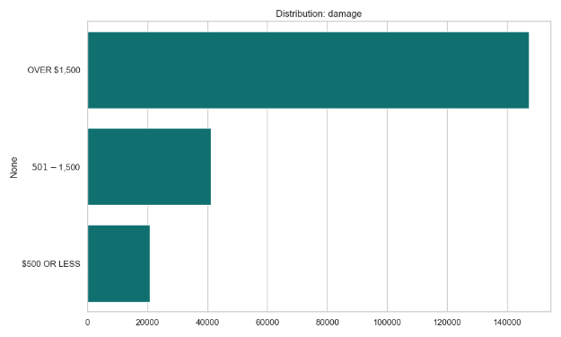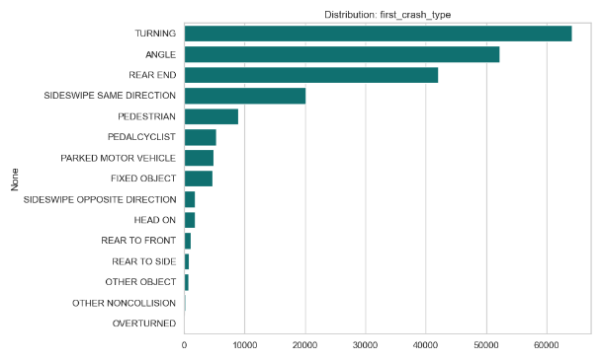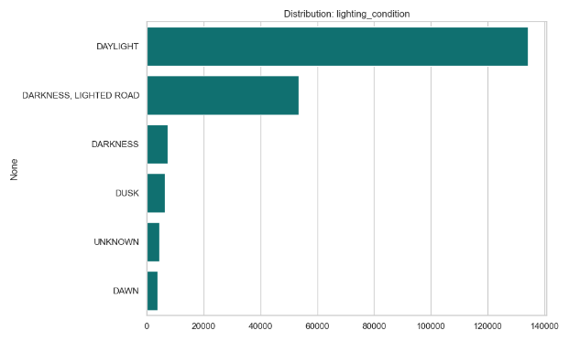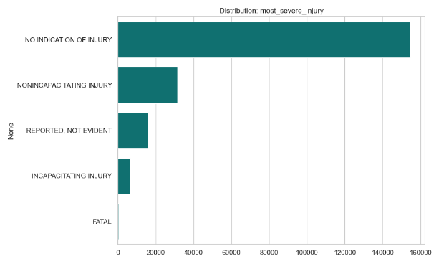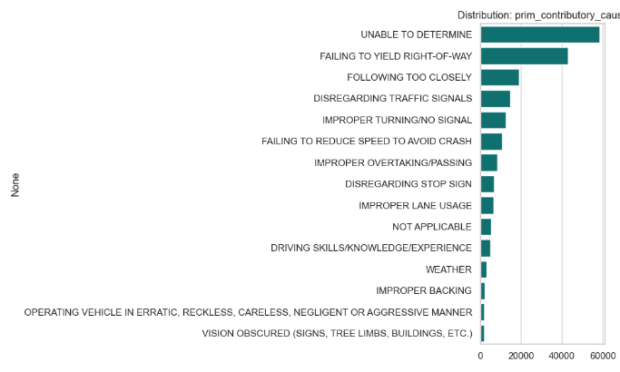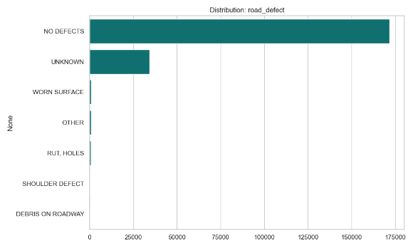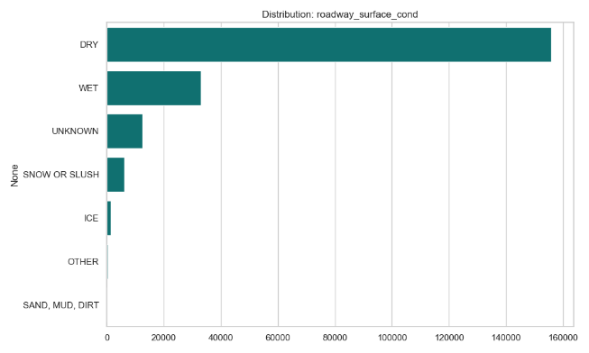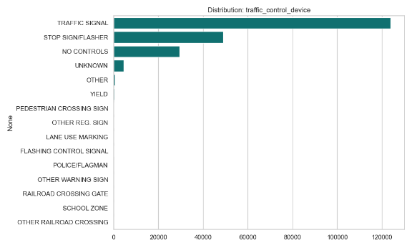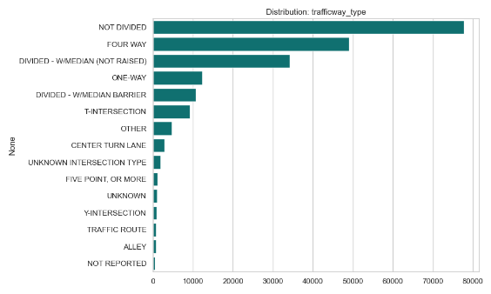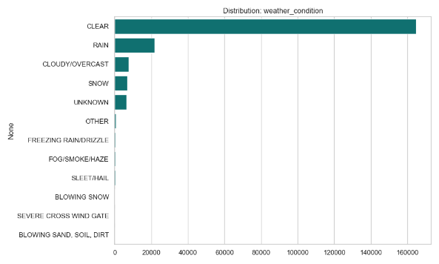

We noticed that variables like road_defect, alignment, and most_severe_injury show extreme class imbalance, where a single category (e.g., "NO DEFECTS" or "NO INDICATION OF INJURY") dominates the vast majority of records. So, in the future, we will have to address this in Lab 3 by applying balancing techniques (like oversampling the minority classes) and in Lab 4 by choosing evaluation metrics that are sensitive to rare events (like Precision/Recall) instead of standard Accuracy, to ensure the model actually learns to detect accidents with defects or injuries.
We noticed that prim_contributory_cause and first_crash_type have high cardinality (a large number of distinct categories), yet many of these categories appear very infrequently. So, in the future, we will have to address this during Lab 3 by aggregating these rare or similar categories into broader groups (e.g., grouping all distraction-related causes together) to avoid creating a model with too many sparse dimensions, which would reduce performance.
We noticed the frequent presence of labels like "UNKNOWN", "UNABLE TO DETERMINE", or "NOT APPLICABLE" across multiple symbolic variables (such as traffic_control_device and weather_condition). So, in the future, we will have to address this by deciding whether to treat these as missing values (and impute them using techniques like KNN) or keep them as a distinct informative category if the lack of information is itself a pattern we want the model to learn.
Outliers Study
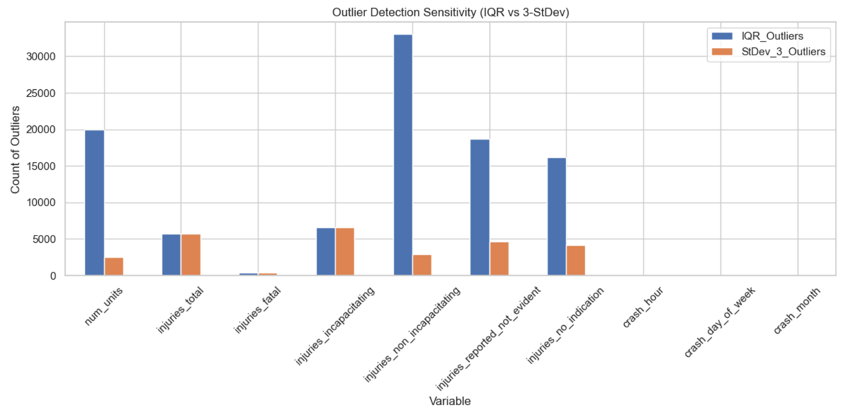
We noticed that the injury-related variables (like injuries_total, injuries_fatal, and injuries_incapacitating) are heavily skewed, where the median is 0 but there are many "outliers" representing severe crashes with high injury counts (e.g., up to 21 injuries in a single crash). So, in the future, we will have to address this in Lab 3 by carefully choosing our scaling method. Standard scaling (Z-score) would be distorted by these extreme values, so we should consider using Robust Scaler or log-transformations. Furthermore, we must not remove these outliers, as they represent the critical "severe" cases we likely want to predict.
We noticed that num_units (number of vehicles involved) has a very tight distribution (mostly 2 units), but statistical outliers exist where crashes involve up to 11 vehicles. So, in the future, we will have to address this by deciding if crashes with a very high number of vehicles are distinct enough to warrant their own category or feature engineering (e.g., a binary flag for "Multi-Vehicle Pileup"), as they might behave differently from standard 2-car collisions.
We noticed that temporal variables like crash_hour, crash_day_of_week, and crash_month do not show statistical outliers (all data points fall within expected ranges like 0–23 hours). So, in the future, we will not need to apply outlier removal or complex transformations to these variables, but we should still treat them as cyclical features (e.g., using Sine/Cosine transformation) in Lab 3 to preserve their time-based nature.

Class Distribution

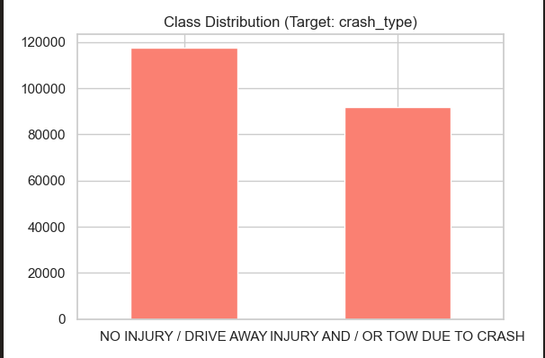
Dataset is pretty balanced
Granularity
In the context of Data Science, Granularity refers to the level of detail or "resolution" of your data. For the traffic_accidents dataset, the goal of this section is to determine if the current data representation is too detailed (creating noise), too broad (hiding patterns), or just right.
Temporal Granularity
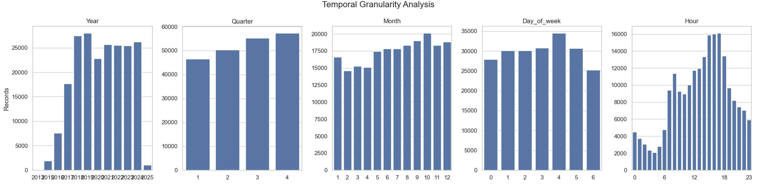
In this section, we assess whether the temporal variables in their raw form provide the optimal level of detail for modeling, or if they contain excessive granularity that requires aggregation (binning).
3.1. Macro & Meso Levels (Year, Quarter, Month, Day)
- Analysis: The distributions for Quarter, Month, and Day of Week are nearly uniform. This indicates that at this specific level of granularity (e.g., distinguishing between Tuesday and Wednesday, or June and July), the data does not provide a strong discriminative signal.
Conclusion: The current granularity is likely too high for the amount of information present.
- Strategy: To improve the signal-to-noise ratio in Lab 3, we should consider aggregating these levels:
  - Group Months $\rightarrow$ Seasons (Winter, Spring, Summer, Fall).
  - Group Days $\rightarrow$ Weekday vs. Weekend.
3.2. Micro Level (Hour)
- Analysis: The Hour variable (0–23) shows a high-resolution bimodal pattern. However, for a predictive model, the precise distinction between 08:00 and 09:00 is less relevant than the semantic context of the time (e.g., "Commuting"). The raw 24-hour granularity introduces unnecessary dimensionality and noise.
- Conclusion: The variable is too granular.
- Strategy: We will bin the hours into broader, semantically meaningful categories such as:
  - Morning Rush (06:00–10:00)
  - Evening Rush (15:00–19:00)
  - Daytime (10:00–15:00)
  - Night (19:00–06:00)
Symbolic Granularity Analysis
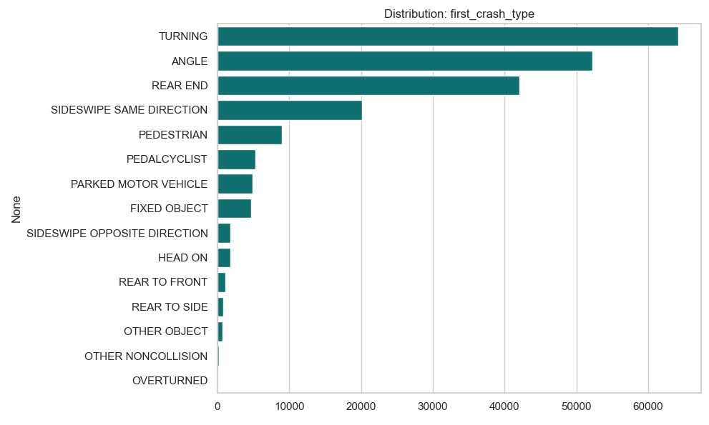
Observation: The variable has 18 categories, but is dominated by the top 3 (TURNING, ANGLE, REAR END), which account for ~75% of data. The tail contains rare but specific types like PEDALCYCLIST or ANIMAL.
Action: Group the rare "Non-Vehicle" collisions together.
Strategy: Create a broader taxonomy such as: Vehicle-to-Vehicle, Vehicle-to-Person/Cyclist, and Single Vehicle/Static.
Consequence: Reduces dimensionality and focuses the model on the dynamics of the crash rather than specific objects.
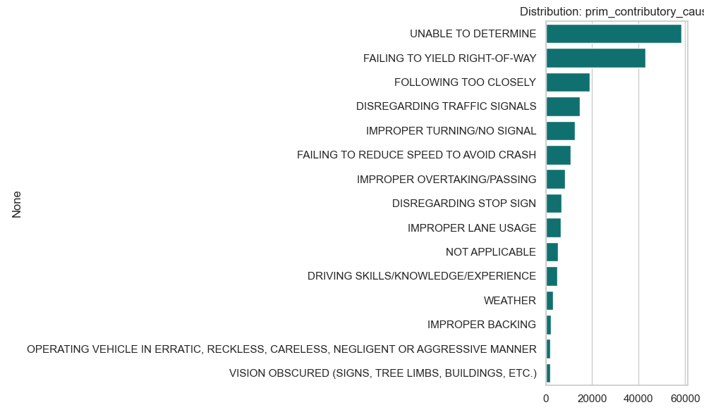
- Observation: This variable exhibits extreme high cardinality (40 distinct causes). There is significant semantic overlap (e.g., "Distraction - Phone", "Distraction - Other"). The top category is "UNABLE TO DETERMINE" (28%), which is a major data quality signal.
- Action: Aggregation based on Root Cause Analysis.
- Strategy: We will map these 40+ codes into high-level groups: Driver Error (Yielding, Following too close), Distracted Driving, External Factors (Weather, Road), and Unknown.
- Consequence: Transforming a sparse 40-class variable into a dense 5-class variable will significantly improve model stability and interpretability.
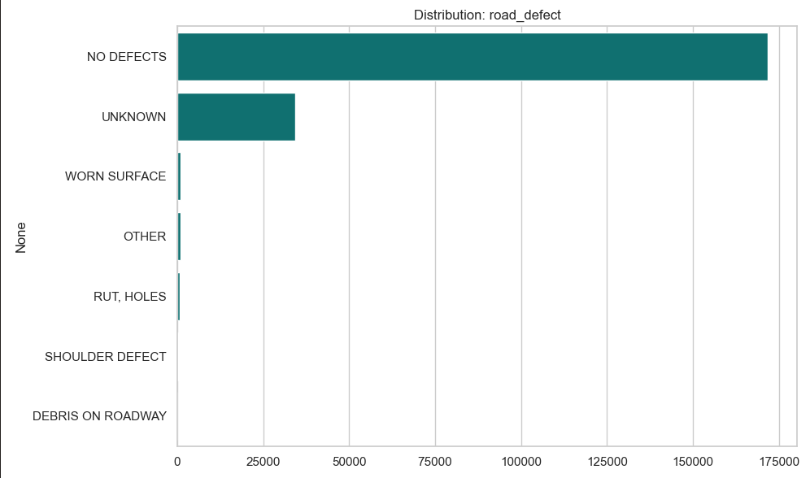
- Observation: Highly imbalanced. "NO DEFECTS" accounts for 82% of records. Real defects like "WORN SURFACE" or "RUT, HOLES" are extremely rare (<1%).
- Action: Binary Classification or Simple Grouping.
- Strategy: Collapse all specific defects into a single boolean flag: Has Defect (Yes/No).
- Consequence: It forces the model to pay attention to the presence of a defect rather than trying to distinguish between a "Rut" and a "Worn Surface," which it has too few examples to learn effectively.
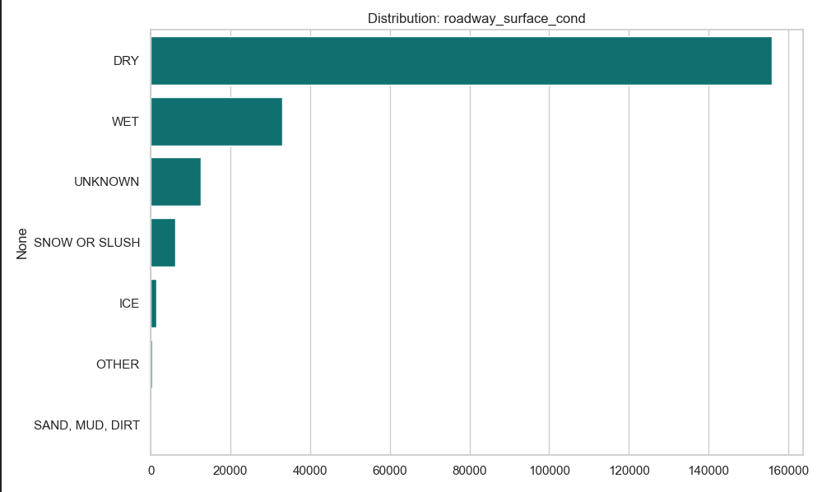
- Observation: Dominated by "DRY" (74%). "SNOW OR SLUSH" and "ICE" are separate but represent a similar hazard context (Slippery).
- Action: Contextual Grouping.
- Strategy: Keep "Dry" and "Wet", but group "Snow", "Slush", and "Ice" into a single "Frozen/Hazardous" category.
- Consequence: Strengthens the signal for winter conditions by combining rare categories.
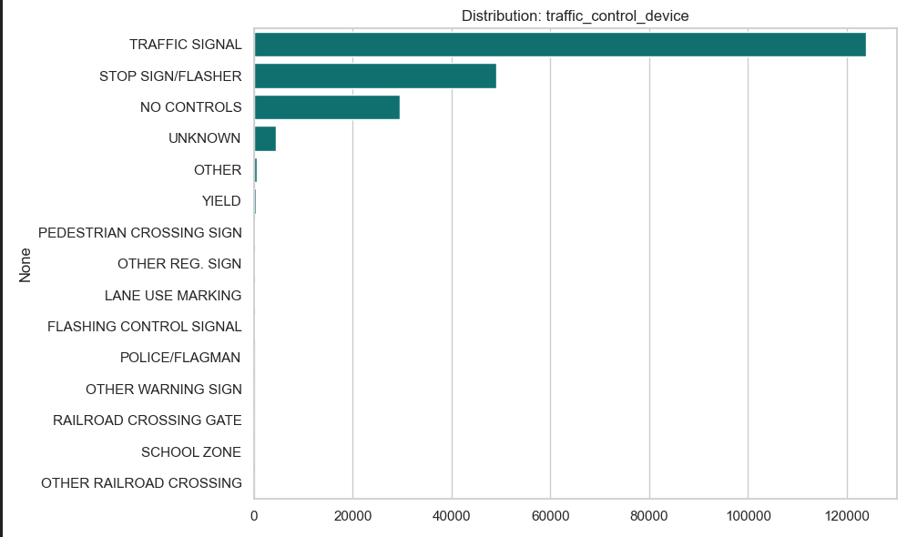
- Observation: There are 19 types, but "TRAFFIC SIGNAL" and "STOP SIGN" dominate. Rare values like "SCHOOL ZONE" or "POLICE/FLAGMAN" appear very infrequently.
- Action: Functional Grouping.
- Strategy: Group into Signalized (Traffic Light), Sign-Controlled (Stop/Yield), and No Control.
- Consequence: Simplifies the variable into three distinct "levels of intersection control," which is likely the underlying factor driving accident risk.
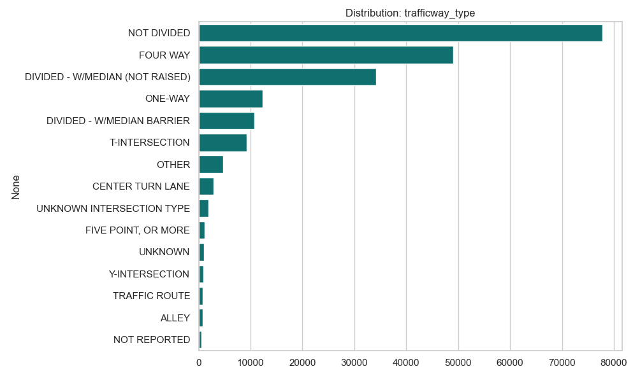
- Observation: 20 Categories. Many are variations of "Divided" vs "Not Divided" (e.g., "Divided - Median", "Divided - Barrier").
- Action: Simplify Geometry.
- Strategy: Reduce to core road geometries: Divided, Undivided, One-Way, and Intersection.
- Consequence: Eliminates noise from administrative distinctions (e.g., median type) that likely have minimal impact on crash dynamics compared to the main road layout.
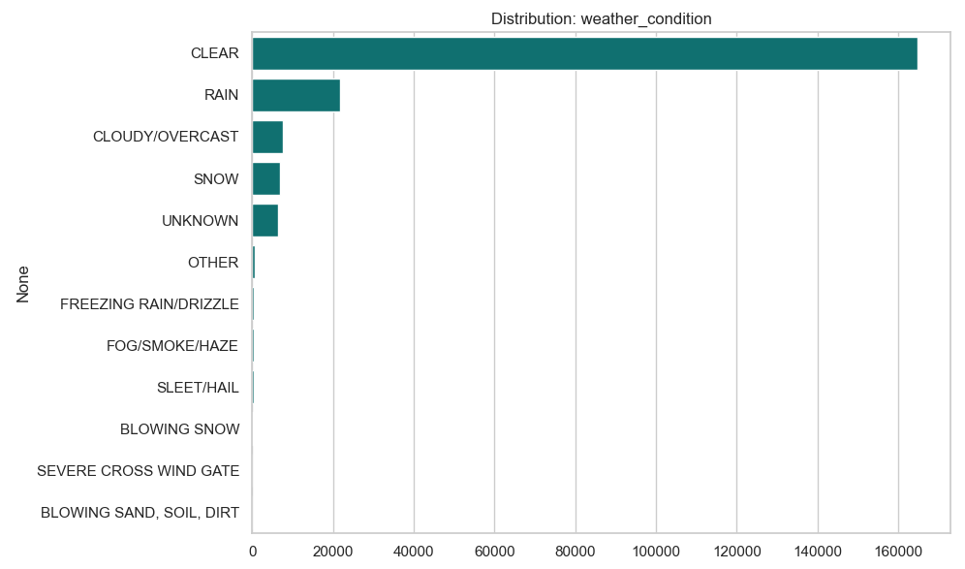
- Observation: Similar to road surface, "CLEAR" dominates (78%). "SNOW", "SLEET/HAIL", "FREEZING RAIN" are all separate, low-frequency events.
- Action: Severity Grouping.
- Strategy: Group into Clear, Rain, and Adverse Winter Weather (combining Snow/Ice/Hail).
- Consequence: Creates a robust "Bad Weather" indicator that aggregates enough samples for the model to learn a meaningful correlation.
Sparsity and Correlation Analysis
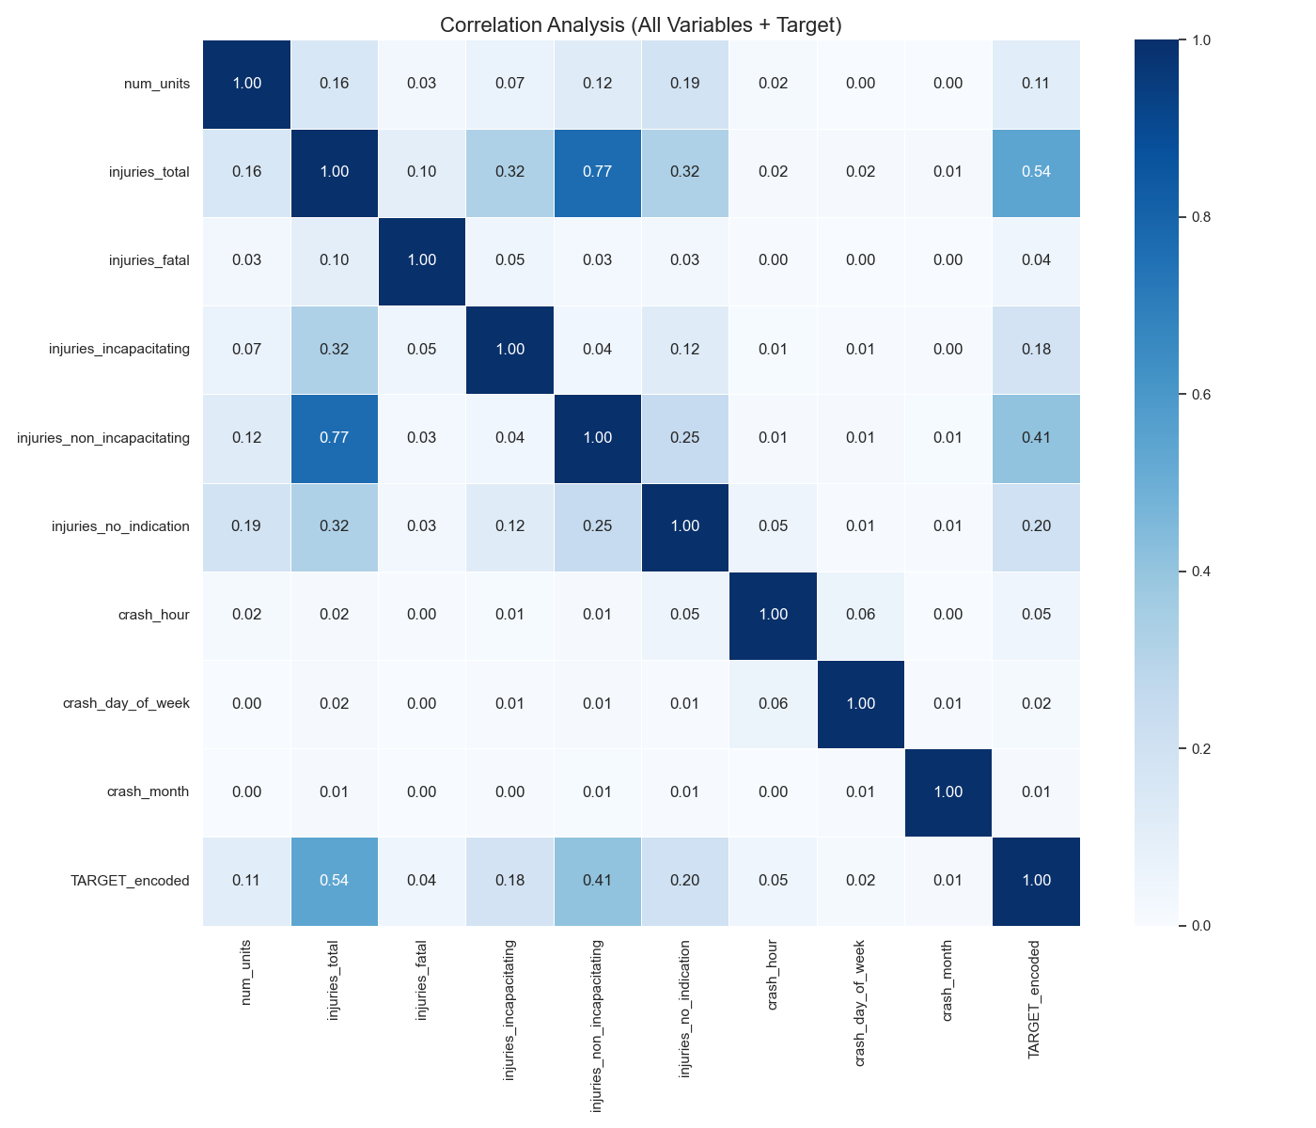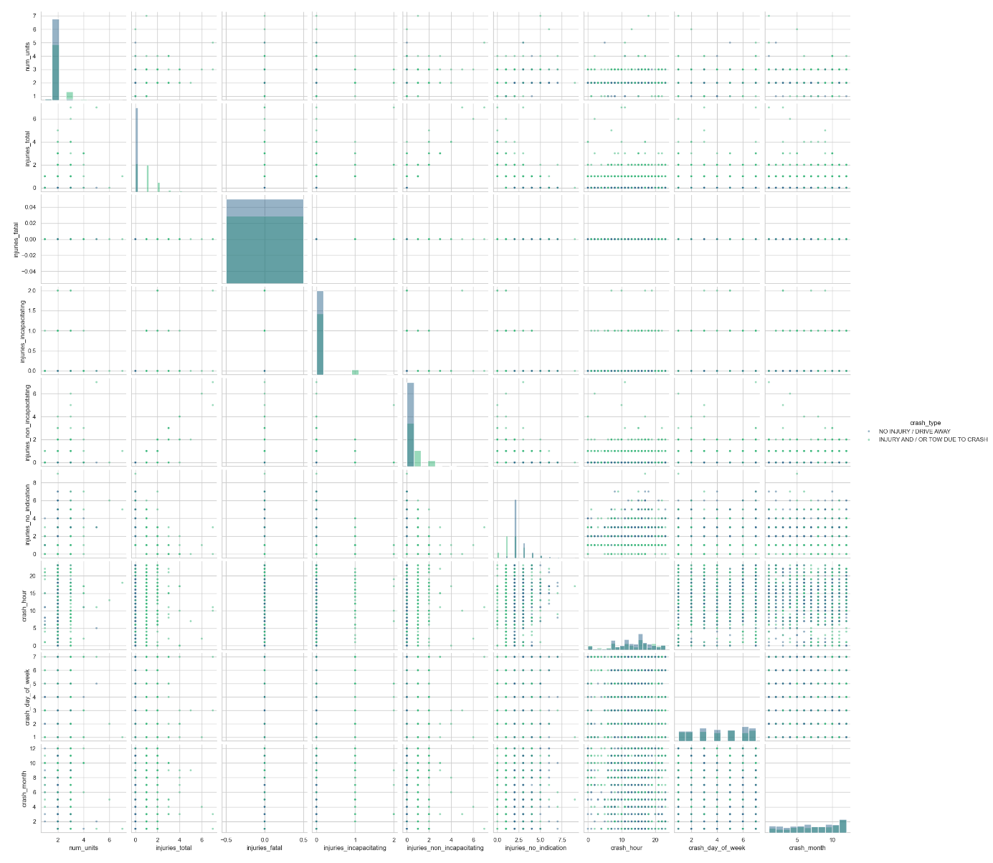

To conclude our data profiling, we performed a multivariate analysis on all numeric variables in the dataset. Our goal was to understand the domain coverage (sparsity) and identify which variables correlate with our target, crash_type.
4.1 Sparsity: Class Discrimination We generated a scatter plot matrix (PairPlot) for all available numeric variables, projecting the records in 2D space and coloring them by class (Injury vs. No Injury).
- High Sparsity & Grid Structure: The scatter plots exhibit a distinct grid-like structure. This confirms that our numeric data is discrete and sparse (e.g., accidents occur at integer hours like 14:00 or 15:00, never 14.5). Most of the feature space is empty, with records concentrated at the axes' origins (0 injuries, 2 units).
- Class Overlap: Crucially, we observe significant overlap between the "Injury" and "No Injury" classes. Even when including all injury breakdowns (injuries_fatal, injuries_incapacitating), the classes are not linearly separable based on predictors like crash_hour or num_units. The "Injury" cases are simply outliers extending from the main cluster, rather than a separate cluster themselves.
4.2 Correlation Analysis We computed the Pearson correlation matrix for all variables, explicitly encoding the target to measure its linear dependence on the features.
- Internal Consistency: We observed strong correlations (>0.7) between injuries_total and its subtypes (e.g., injuries_reported_not_evident). This is expected, as the total is the sum of these parts.
- Independence of Predictors: Most importantly, the target variable (TARGET_encoded) shows negligible correlation (near 0) with the independent predictors:
  - crash_hour: 0.01
  - crash_day_of_week: 0.00
  - num_units: 0.04
- Conclusion: There is no single numeric variable that linearly predicts the accident severity.
4.3 Impact on Future Work The high sparsity and lack of linear correlation have two major consequences for our project:
- Modeling Strategy: Since the classes are not linearly separable, simple algorithms like Logistic Regression may underperform. We must prioritize Non-Linear Models (e.g., Decision Trees, Random Forests) in Lab 4 that can learn complex decision boundaries.
- Data Preparation (Lab 3): The raw numeric variables provide weak signals. We will need to focus on Feature Engineering—specifically, transforming the symbolic variables (like prim_contributory_cause) and binning the temporal variables—to create new features that correlate better with the target.

